Experiment 6: Develop a Product Selling Application as SaaS
Aim
To develop a cloud-based Product Selling application using Zoho Creator for online product management and sales.
Software Used
- Zoho Creator
- Deluge Workflow
- Web Browser
Algorithm
- Create Customer Registration form.
- Create Product Details form.
- Create Shopping Cart form.
- Create Order form.
- Create Payment form.
- Calculate order amount.
- Process payment.
- Generate sales reports.
Output:
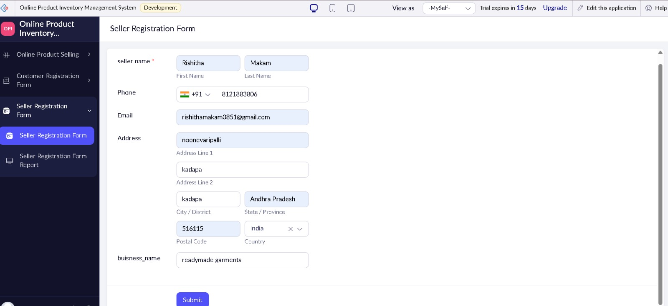

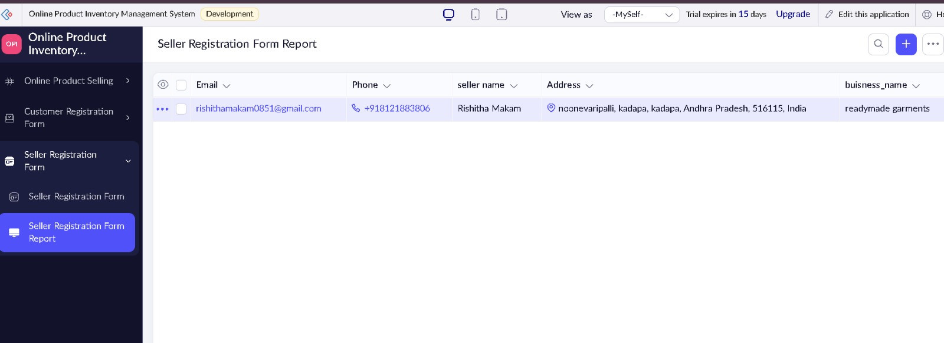
Result:
A SaaS-based Product Selling application was successfully developed and tested for managing products, orders, and payments online.

